- Open up Microsoft Word. Look in the Start Menu. If you don’t see it in your shortcut list, click All Programs>Microsoft Office. This is how you can find Powerpoint and Excel, too.
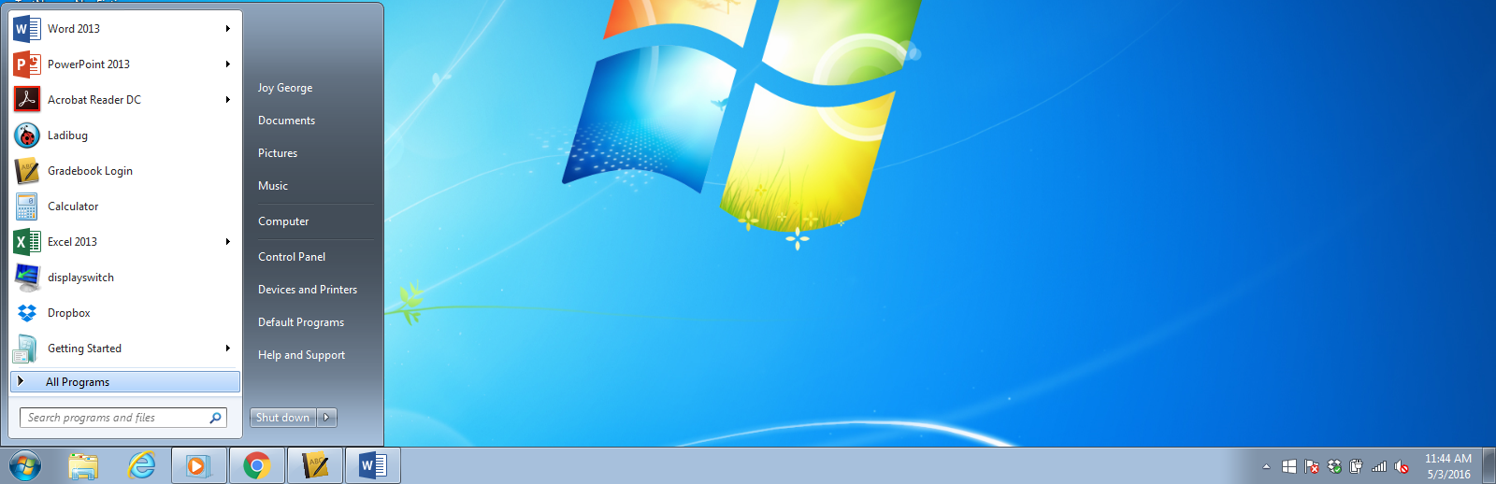
- Once open, the first step to take is to save your document on your flash drive. Documents saved on the school computers will not stay saved!
  - File>Save As>Browse>Computer>Flash Drive
  - Be sure to save your document in an easy-to-identify way for teachers: lastnamefirstinitial_papertitle_block is a good way.
Example: Georgej_formattingadocument_2A
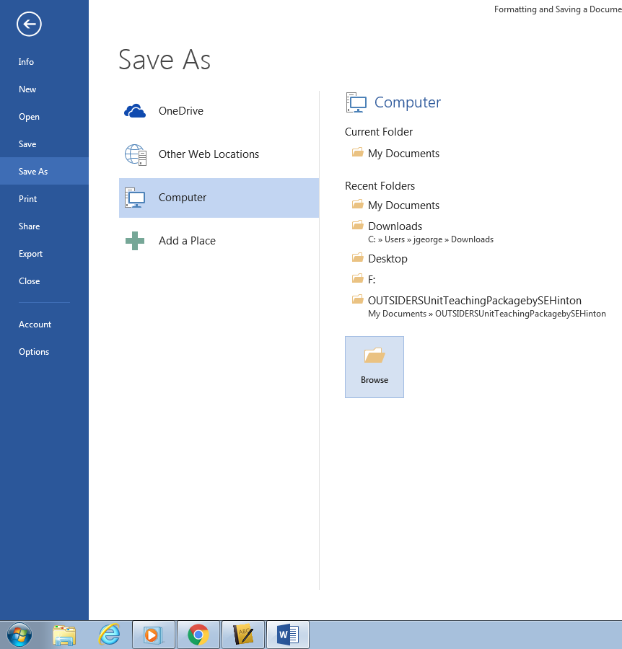
- Set up your document with the appropriate settings—Times New Roman, 12pt font, double-spaced.
Font Left/Center/Right Justify Double-Space (2.0)
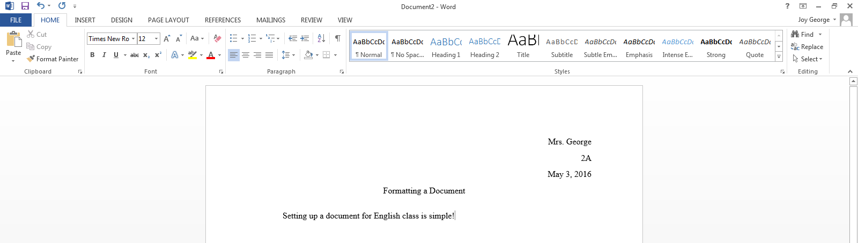
- Type your name(press enter), class(press enter), date(press enter) in the top right-hand corner.
- Type the title in the center and press enter.
- Go back to the left side of the document, indent by hitting TAB, and begin typing. You should see a lightning bolt that indicates auto-formatting is on.
- At the end of each paragraph, press enter. Auto-formatting, if set up, will indent immediately for you.
- Spell/grammar check before submitting a paper.
Remember—always submit your best work! Take pride in your assignments!
- Open up your Internet Browser and go to the BVCPS homepage and click on “Sign In.”
- Log in with your school ID and password. Your ID should be firstname.lastname@bvstudent.net. The password is whatever you chose to set it as.
(I have the list at my desk if you need to remember.)
- At your inbox, you may have e-mails from teachers to respond to. If so, you may click that letter and respond. If you need to start a new e-mail, click “Compose.”
- When writing your e-mail, do the following:
  - Type in the address of the person you’re e-mailing. Teachers use this format:: joy.george@bvcps.net
  - Type a clear subject—people get lots of e-mails and need to know what they’re about immediately. Be sure to include your block and name for easy identification.
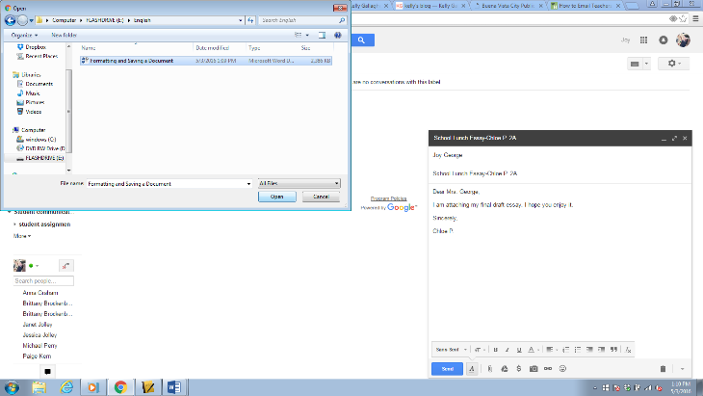
  - Type your message—it doesn’t need to be long! Remember, an e-mail is a professional correspondence between you and your teacher. Check capitalization, punctuation, and spelling. Be sure to include a salutation and a closing.
  - If you need to attach a document, click the paperclip, and find your document on your flash drive.

Note: If you have to e-mail from a personal e-mail account, make sure it is has a school-appropriate address, and remember: what goes on the internet stays on the internet! Be polite.

